

CASE STUDY: 03
Name: Bakery Ordering System
Submitted to: Ma’am Onizha Dated: 02/10/2026
Group Leader: Sharif Ullah (04072413006)

Group Members: Shukria Farzan (04072413064), Sayed Mehmood (04072413007)

Domain Model

Bakery Ordering System — Domain Model

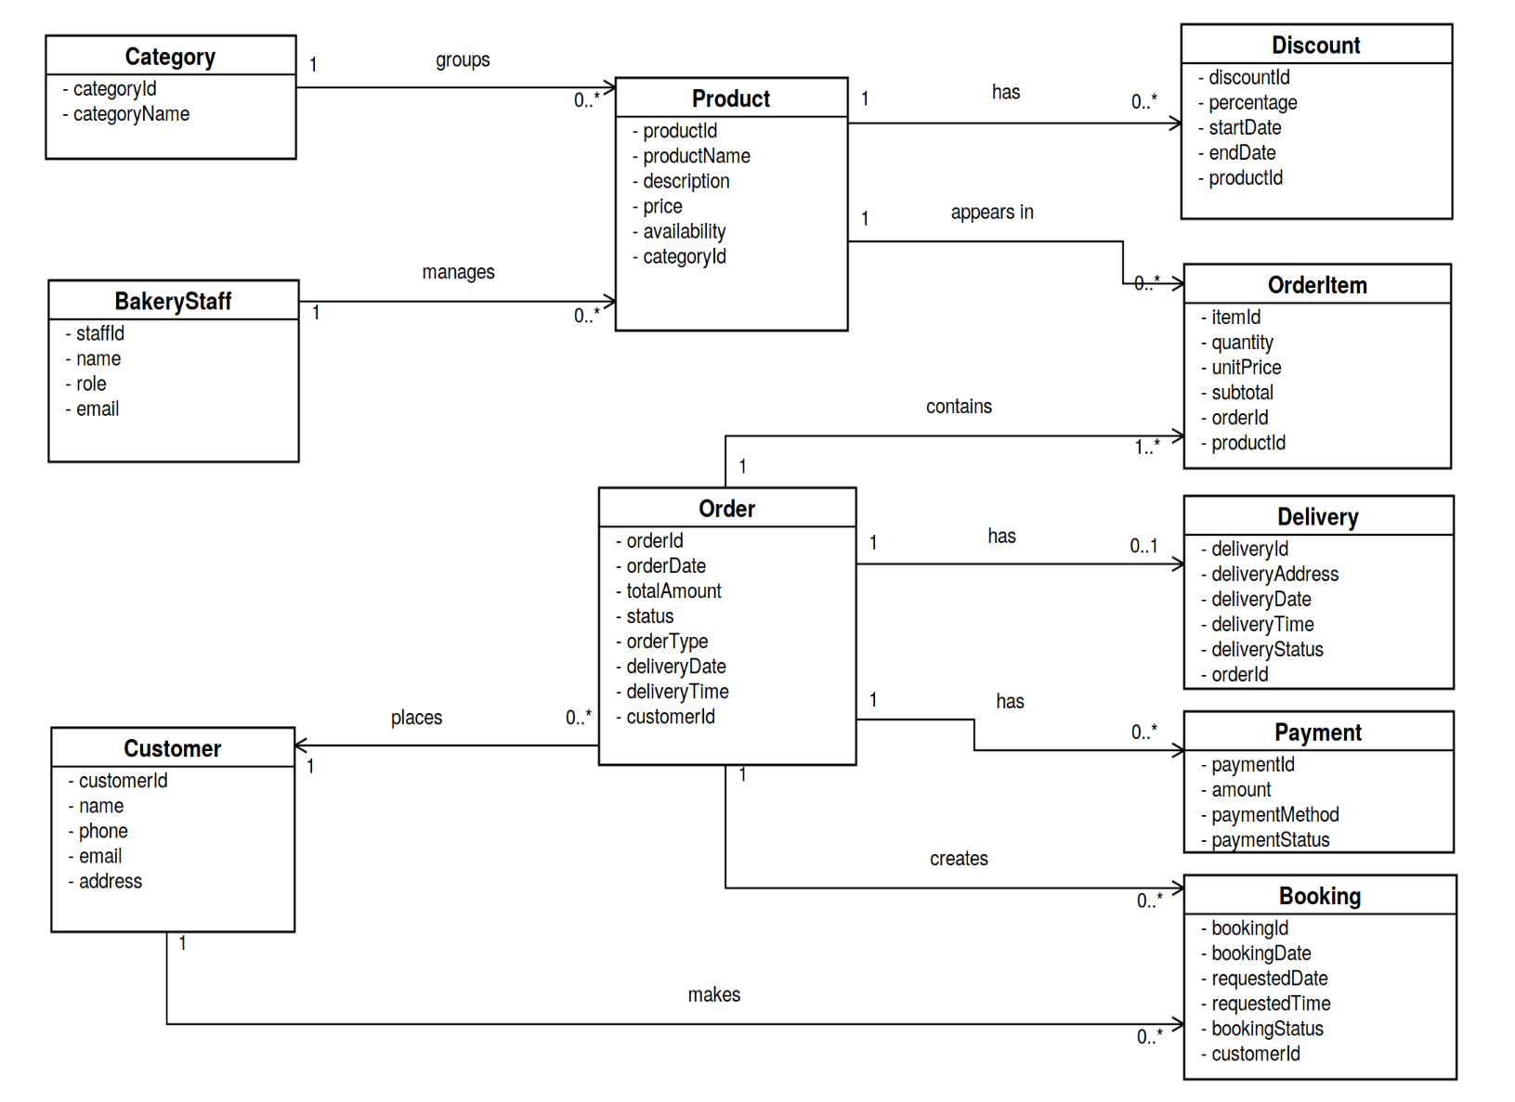

Sharif Ullah (04072413006)

Use Case Text: Place Order Inputs:
  - productId
  - quantity
  - orderInfo

Outputs:
- orderId
- orderStatus
- Primary Actor: Customer

Preconditions
- The customer can access the bakery system.
- Products are available.

Success Scenario
  - Customer views the available bakery products.
  - Customer selects the required products.
  - Customer adds the selected products to the order/cart.
  - Customer reviews the selected items and quantity.
  - Customer provides the required order and delivery information.
  - Customer confirms the order.
  - The system validates the order details.
  - The system creates the order.
  - The system displays the order confirmation.

Alternative Scenario
- A selected product is unavailable.
- The system informs the customer that the product is unavailable.
- The customer removes the unavailable product or selects another product.
- The customer submits the order again.

Postconditions
- The order is successfully created.
- The order details are stored in the system.
- The customer receives an order confirmation.

User Stories
User Story 1:
As a customer, I want to select bakery products and place an order so that I can purchase my
required items easily.
  - Who: I am a customer of the bakery ordering system.
  - What: I want to select bakery products and place an order.
  - Why: I can purchase the items I need.

Acceptance Criteria:
- Scenario: Successful order placement
- Given: products are available and the customer has selected a product.
- And: the selected products and quantities are shown in the order.
- When: the customer confirms the order with valid order information.
- Then: the system creates the order and returns the order ID and order status.
User Story 2:
As a customer, I want to be notified when a selected product is unavailable so that I can remove it
or choose another product.
  - Who: I am a customer of the bakery ordering system.
  - What: I want to know when a selected product is unavailable.
  - Why: I can change my order before submitting it.
Acceptance Criteria:
- Scenario: Unavailable product
- Given: a selected product is unavailable.
- When: the customer submits the order.
- Then: the system displays an unavailable-product message.
- And: the customer can remove the product or select another product.

System Sequence Diagram: Place Order

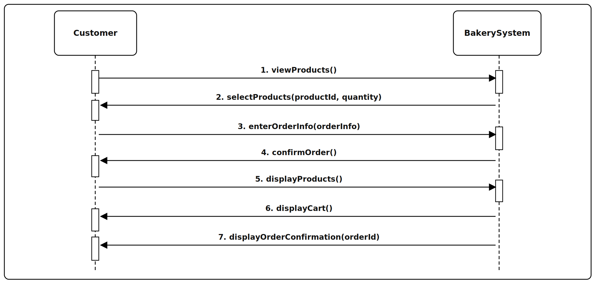

Shukria Farzan (04072413064)

Use Case Text: Make Payment Inputs:
- paymentMethod
- paymentInfo
- amount

Outputs:
- paymentStatus
- paymentId
- Primary Actor: Customer

Preconditions
  - The customer has created an order.
  - The order amount is available.
  - A valid payment method is available.

Success Scenario
- Customer confirms the order.
- The system displays the available payment options.
- Customer selects a payment method.
- Customer enters the required payment information.
- The system sends the payment request for processing.
- The payment service processes the payment.
- The system records the payment.
- The system displays a payment confirmation.

Alternative Scenario
- The payment information is incorrect or the payment is declined.
- The system displays a payment failure message.
- The customer corrects the payment information or selects another payment method.
- The customer tries the payment again.

Postconditions
  - Successful payment is recorded.
  - The order is ready for further processing.

User Stories
User Story 1:

As a customer, I want to pay for my order through the available payment options so that my order can be
processed successfully.
Making payment for an order
    - Who: I am a customer of the bakery ordering system.
    - What: I want to select a payment method and enter my payment information.
    - Why: I can pay for my order.
Acceptance Criteria:
- Scenario: Successful payment
- Given: a valid order and amount are available.
- And: a payment method is available.
- When: the customer submits valid payment information.
- Then: the payment service processes the payment and the system records the payment ID and status.
User Story 2:
As a customer, I want the system to inform me if my payment is declined so that I can correct the issue or choose another payment method.
    - Who: I am a customer of the bakery ordering system.
    - What: I want to know when my payment is declined.
    - Why: I can correct the information or try another payment method.
Acceptance Criteria:
- Scenario: Payment failure
- Given: the payment service rejects the payment.
- When: the system receives the failure response.
- Then: the system displays the payment status.
- And: the customer can retry with corrected information or another payment method.

System Sequence Diagram: Make Payment

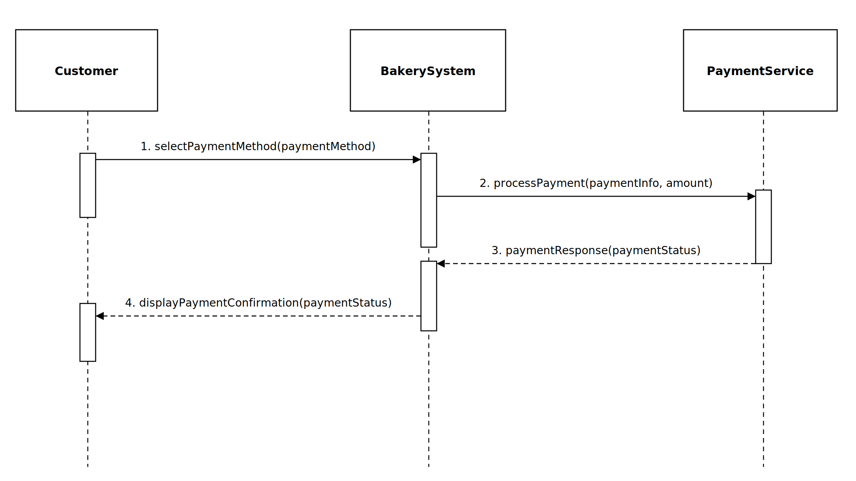

Sayed Mehmood (04072413007)

Use Case Text: Manage Products Inputs:
- productData

Outputs:
- productData
- productStatus
1. Primary Actor: Bakery Staff

Preconditions
  - Bakery staff is logged in.
  - Staff has permission to manage products.
  - The product management section is available.

Success Scenario
- Staff selects Manage Products option
- The system will show the product management page
- Add / Update / Delete – Bakery Product
- The staff member enters the necessary information about the product
- The system validates the information
- The system saves the updated information
- The system shows a success message

Alternative flow
4a. Invalid Product Information. Staff enters incomplete or invalid product information.
- The system detects the error.
- The system displays an error message.
- Staff corrects the information and submits it again.

Postconditions
• The product information is successfully added, updated, or deleted.
• The product list contains the latest information.

• The updated product information is available to customers.
User Story 1:
As bakery staff, I want to add a bakery product so that the new product appears in the product list.
    - Who: I am a bakery staff member.
    - What: I want to add or update product information.
    - Why: Customers can see the correct bakery products.
Acceptance Criteria:
- Scenario: Valid product information
- Given: the staff member has permission to manage products.
- When: the staff member enters valid product information.

- Then: the system saves the product information.
- And: the product list shows the latest information.
Story 2:
As bakery staff, I want to update product information so that the product list contains current information.
- Who: I am a bakery staff member.
    - What: I want to remove a product that is no longer available.
    - Why: Customers do not see an outdated product.
Acceptance Criteria:
- Scenario: Product removal
- Given: the staff member has permission to manage products.
- When: the staff member removes a product.
- Then: the system saves the product change.
- And: the product is no longer shown as an available product.

System Sequence Diagram: Manage Products

